**VANUR GOVERNMENT ARTS AND SCIENCE COLLEGE**

**BULID AN EMPLOYEE TRAVEL APPROVAL APPLICATION FOR CORPORATES**

PROJECT BASED EXPERIENTIAL LEARNING PROGRAM

By

Sanjay sagar.v

III B.SC

MATHMATICS

**OVERVIEW**

This project covers the role and process involved in an applying travel application for their project,from their respective company .It depicts the details and purpose of travelling ,also includes the destination ,hotel , departure and travel expense. This project can cover all types of travel application and able to make the process efficient and reliable

PURPOSE

The project can be used to apply application for travel approval can be made easy and not required much work and time. It benefits corporate and MNC’s most. The search of hotel and others are also available to make it easy to accsess and use it

you receive an application and add it to the ATS, the tool allows you to process and analyze the same with increased automation and accuracy.

# problem Deffinition & Design Thinking

* 1. **Empathy Map**
  2. 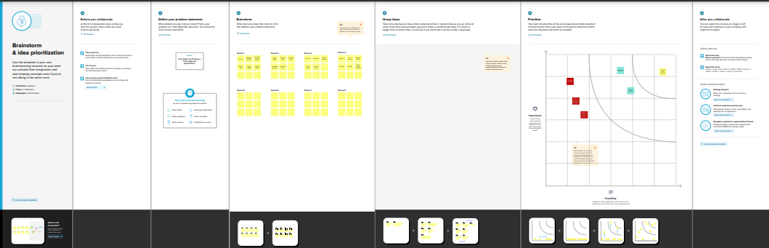**Ideation & Brainstorming map Screenshot**

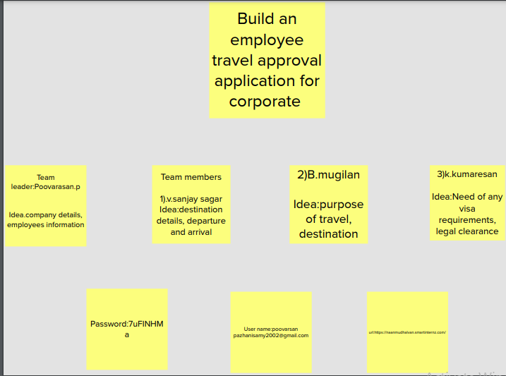

1. **RESULT**
   1. **Data Model:**

|  |  |  |
| --- | --- | --- |
| Object Name | Fields in the Object | |
| Field label | Data type |
| Object 1 | Department | Text |
| Object 2 | Travel approval | Auto Number |
| Object 3 | Expense item | Auto Number |
| Object 4 | Amount | Currency |

* 1. **Activity & Screenshort**

**Create an object**

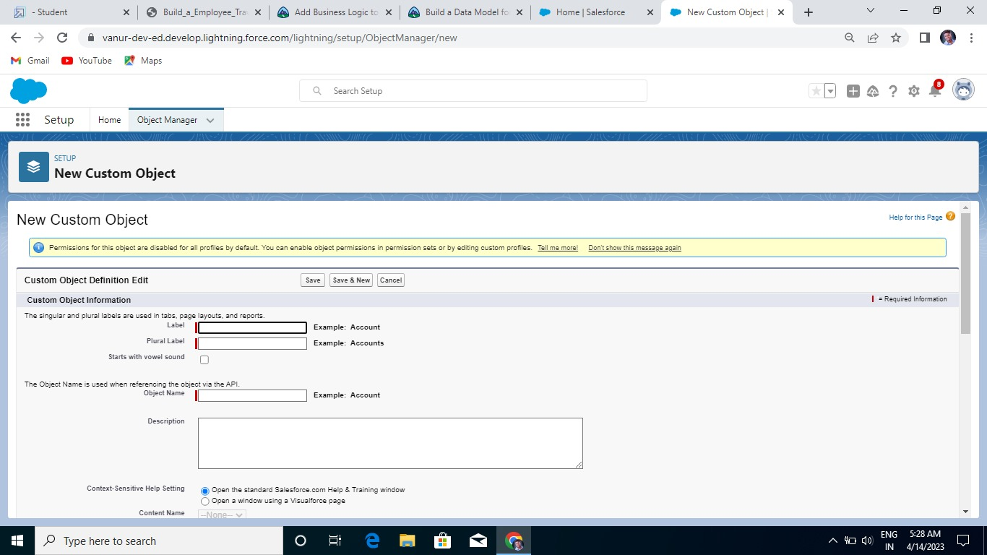

**Activity 2:**

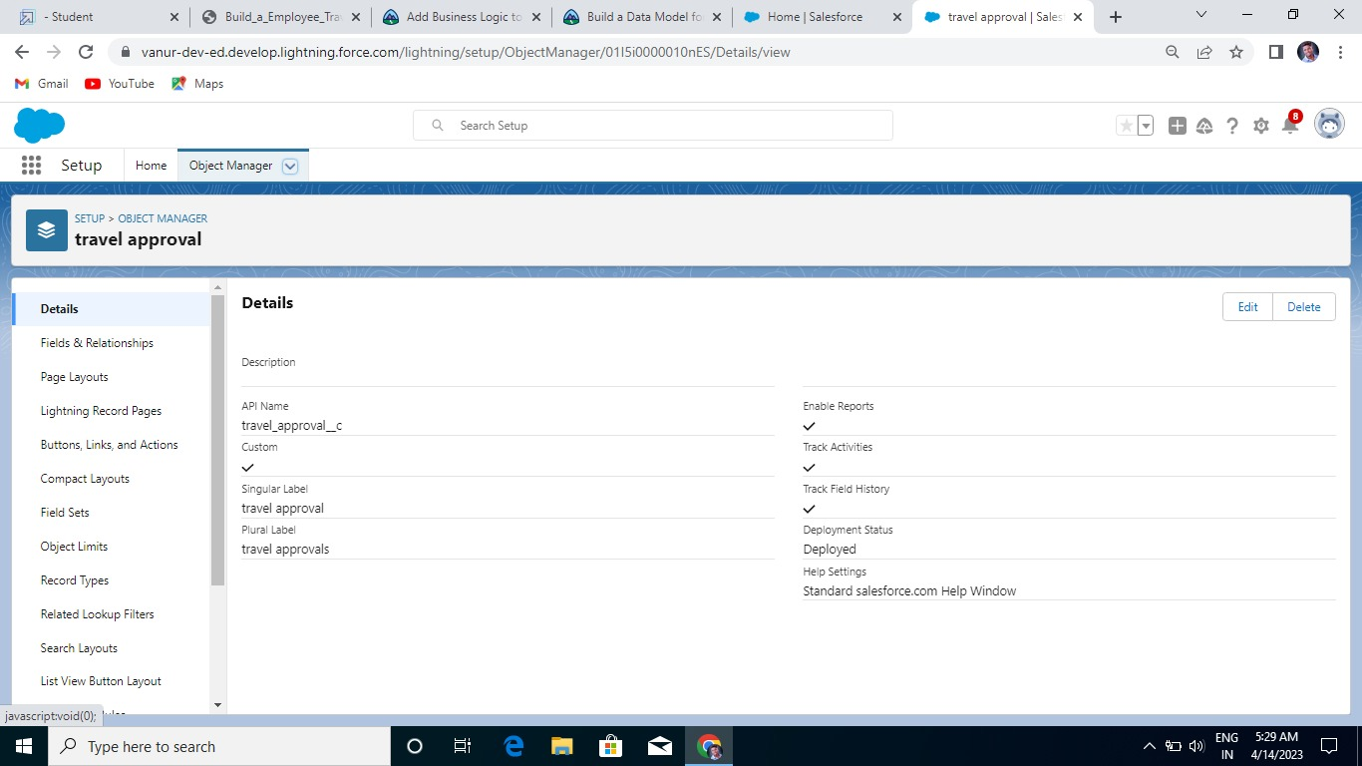

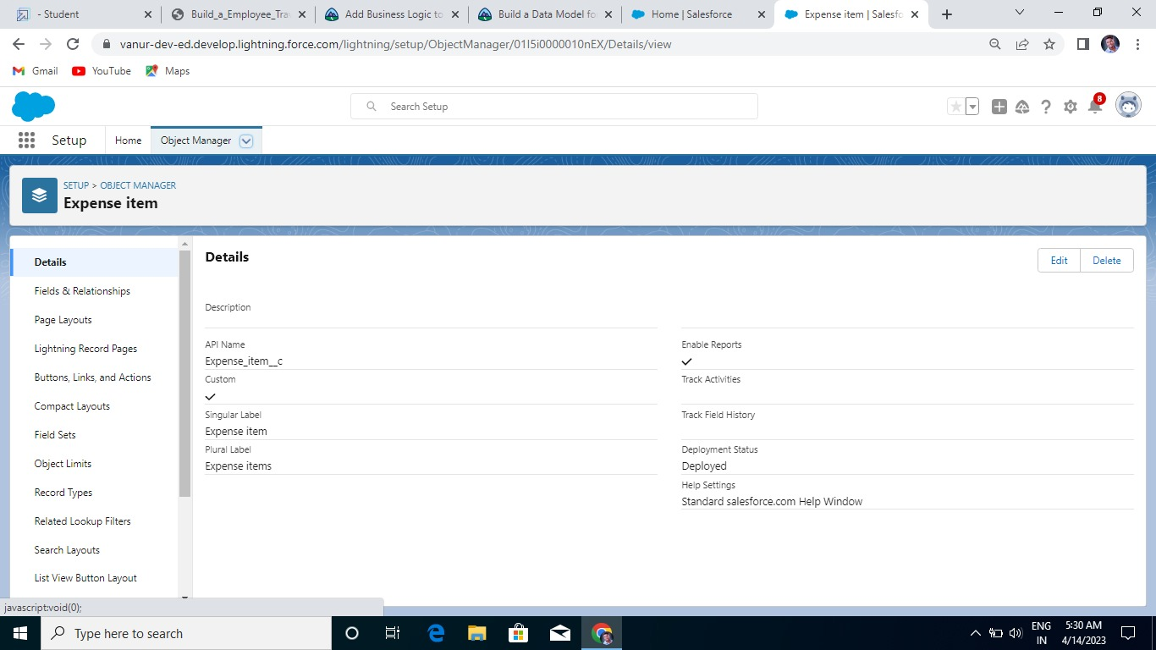

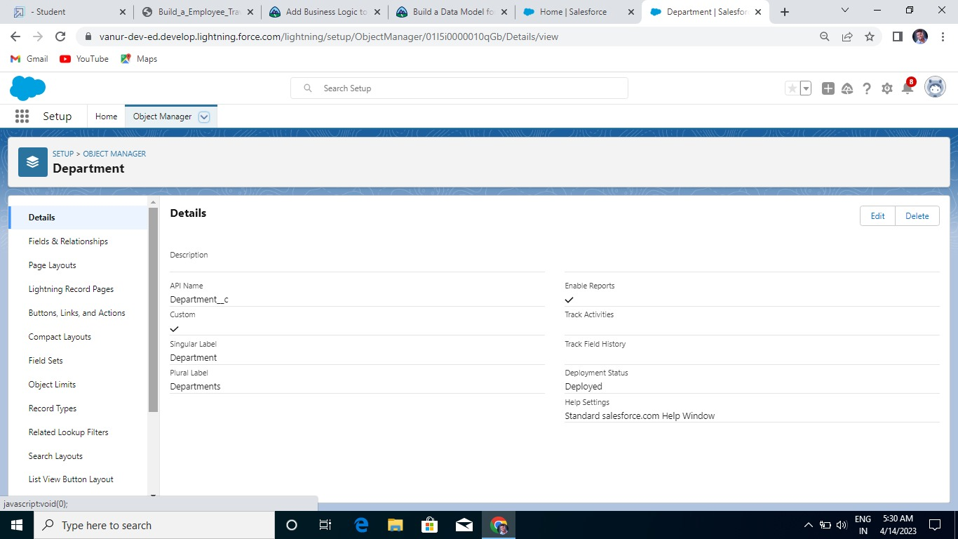

**2. Create a custom fields:**

**Activity 1:**

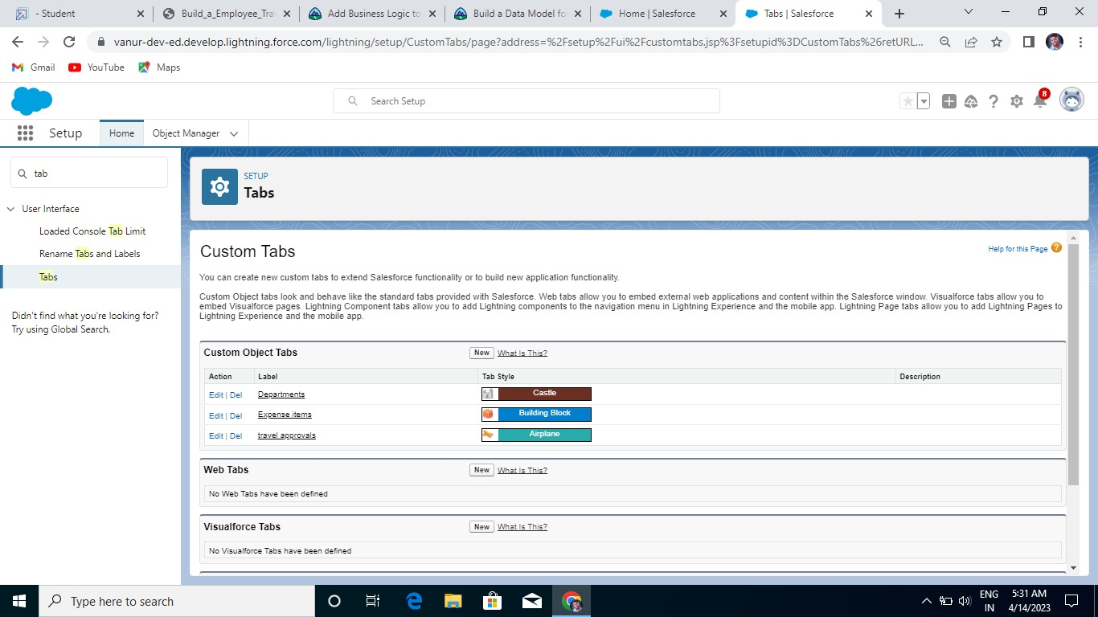

**Activity 2**

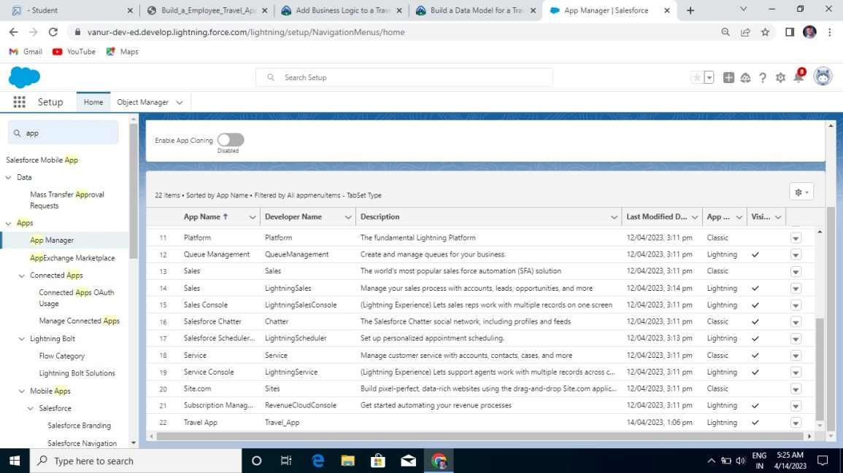

**Activity 3:**

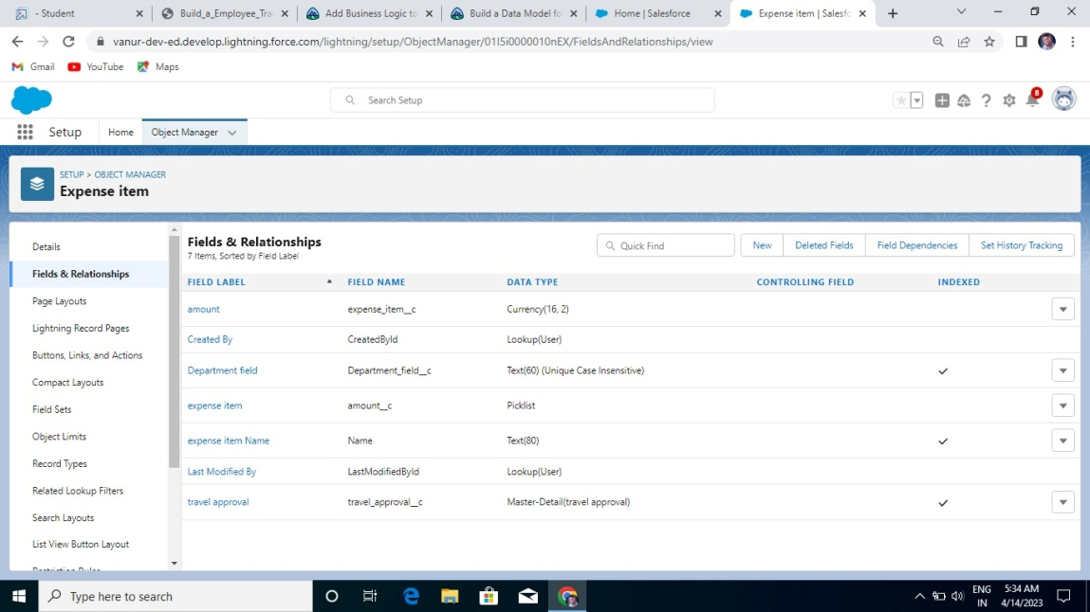

**Activity 4:**

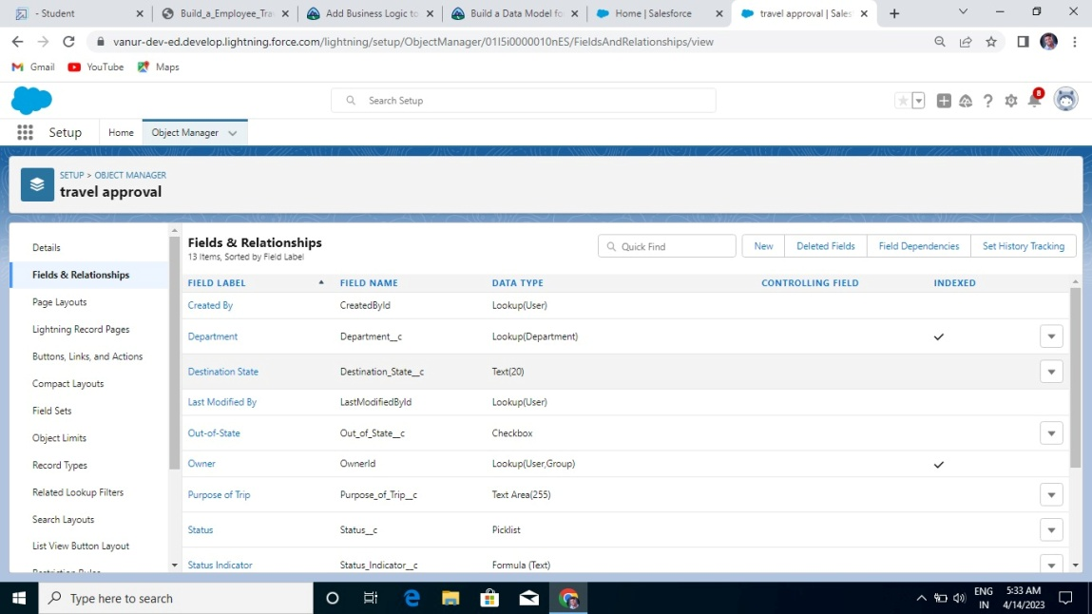

**Create a Tab: Activity 1:**

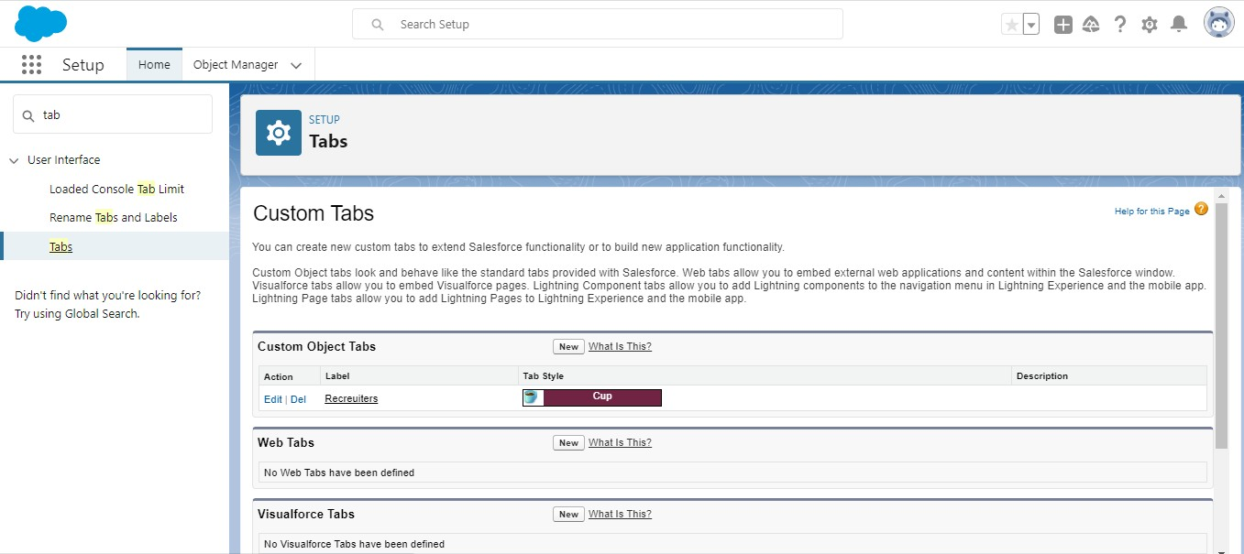

**Create a Custom profile: Activity 1:**

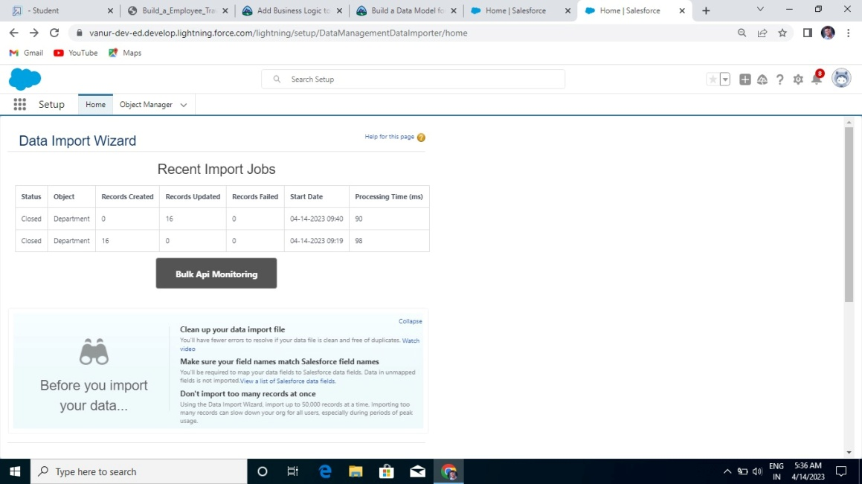

**Activity 2:**

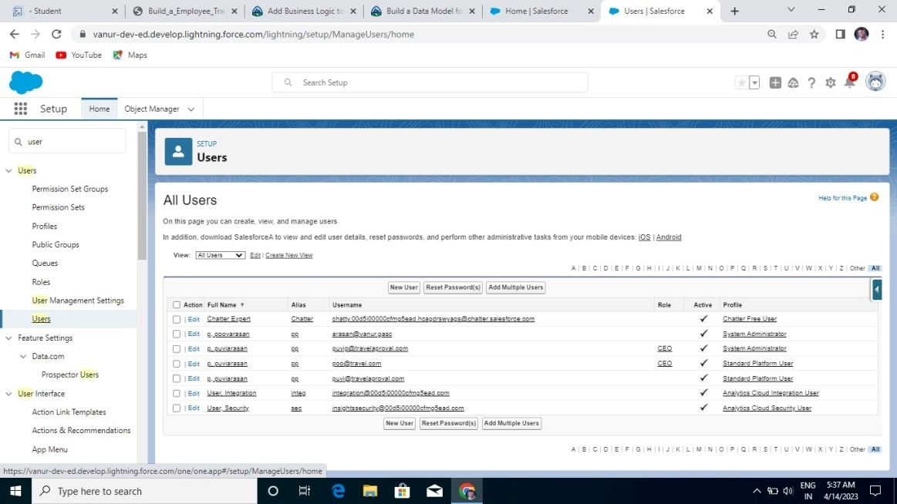

## To Create a User: Activity 1:CUSTOMIZE TRAVEL APPROVAL OBJECT

## PAGE LAYOUT

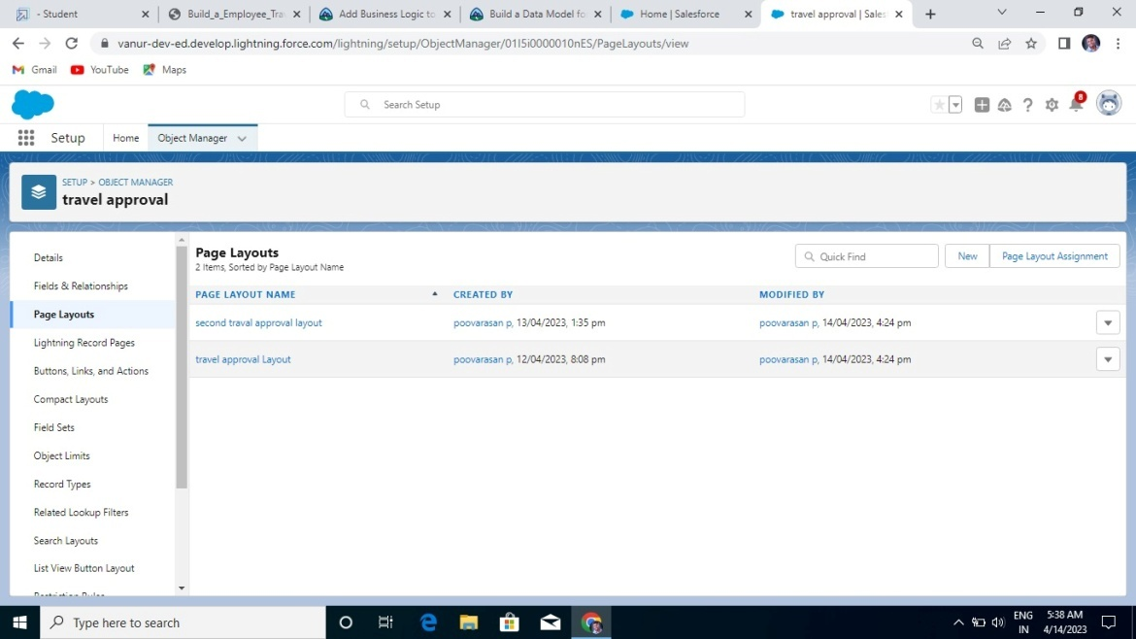

**Create a Sharing rule:**

**Activity 1:**

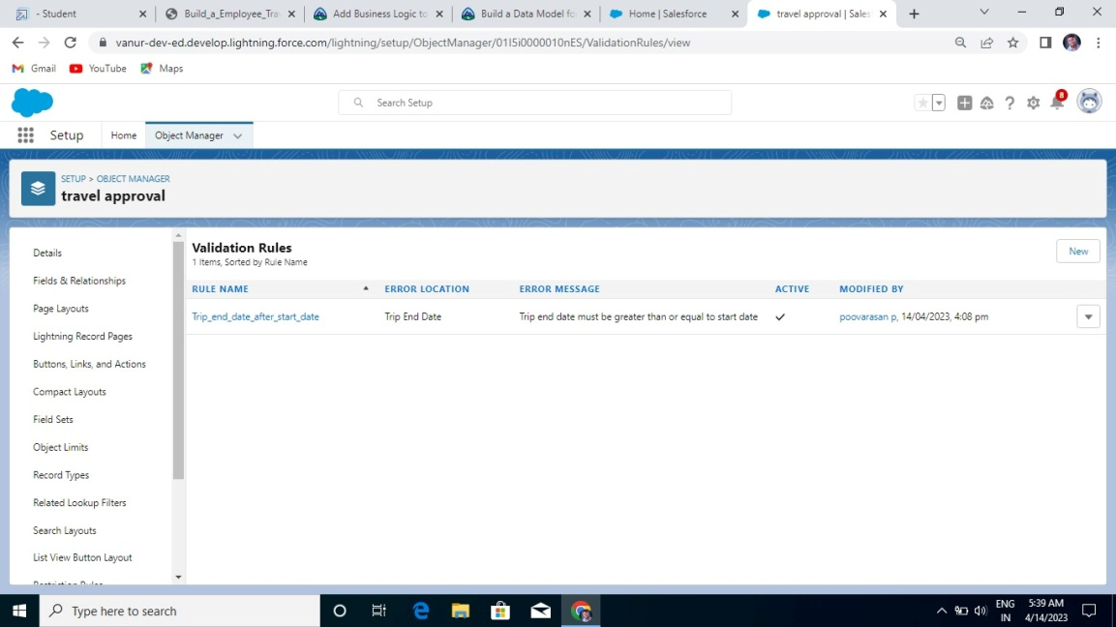

**Create a reort:**

**Activity 1:**

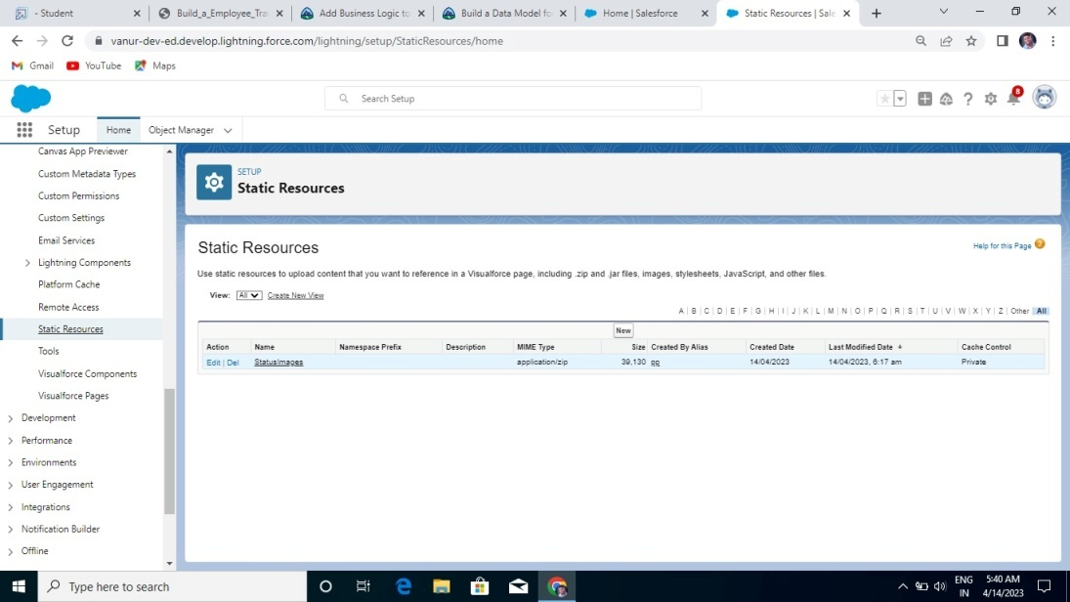

1. **Trailhead profile Public URL:**

**Team Leader(POOVARASAN.P)- https://trailblazer.me/id/poovp**

**Team Member(SANJAY SAGAR.V)-** **https://trailblazer.me/id/ssagar182**

**Team Member(KUMARESAN)-** https://trailblazer.me/id/kresan4

**Team Member(MUGILAN.)-** <https://trailblazer.me/id/mbvmks>

**Advantage:**

1. Facilitates Cost Control

With a strict business travel policy, you can tightly control all the expenses incurred during a business trip. This includes travel, food, accommodation, and other travel-related expenses.

For instance, with a strict travel policy, your employees can be mandated to book flights well in advance. Moreover, you can also ask them to book from a defined list of hotels and flights to leverage deals and discounts. This helps you control travel costs and prevents employees from incurring additional expenses.

2. Ensures Travel Policy Compliance

With a strict business travel policy, you can ensure policy compliance by setting clear and well-defined guidelines for all your employees

3. Better Risk Management

When employees go on business trips, they can encounter various risks such as accidents, political and civil unrest, natural disasters, etc. In order to mitigate such risks, you, as a company owner, can protect your employees and minimize potential harm by implementing a strict travel policy that addresses these risks.

## Disadvantages:

A flexible travel policy allows employees to make their own travel decisions and arrangements. This can lead to a lack of inconsistency and increased costs. For instance, an employee may decide to book a flight at the last minute or book a hotel at a higher rate due to limited availability.

With such a policy, it becomes difficult for your travel managers or the finance team to track and monitor expenses. This can lead to overspending and difficulty reconciling expenses. For instance, employees may use personal credit cards or choose expensive options without proper approvals, increasing expenses.

1. **Applications**

## 1.As a traveling app it requires information details regarding employee and their company.

**2.It can be used in requesting travel approval from their respective company.**

## 3.Used in the field of travel booking agencies and etc.

## 4.The processing time requires few minutes and the process is efficient.

**CONCLUSION**

Here we've presented the look of a travel Approval Application on the Salesforce Platform which might provide

the users with the specified travel assistant and also for the upper authorities to require care of the expenses at

any point of your time through multilevel approvals of the travel request. Here the user can upload the bills to

the cloud any time which is more efficient and productive. Travel Approval Application allows us to

arrange and monitor travel plans and expense reports for our organization using Salesforce Platform. When it

makes all the difference in closing and winning of any deal, this app provides you that perfect solution as a

manager to timely approve the request and monitor travel plans and expenses for our organization, making

them more efficient to use.

**Future Scope:**

 It is clear that the online travel business is a booming industry and will continue to be so. Rising to the occasion, even small travel agency owners are also looking to go online. For them, an online travel portal can be an ideal fit.